

***CERTIFICATION OF ACHIEVEMENT***

***THIS IS TO CERTIFY THAT***

|  |  |
| --- | --- |
| Harrison Mfonobong Joshua | Student 1318525 |
| Oguadinma Chinemelum precious | Student 1325516 |
| Abdulrasak Abubakare Babatunde | Student 1317246 |

***Successfully designed VINEGAR food website.***

**Table of Contents**

**Acknowledgement 3**

**E-Project synopsis 4**

**E-Project Analysis 5**

**E-Project Design (Data flow diagrams) 7**

**Screenshots 8**

**Developers guide 19**

# **Acknowledgement**

All thanks to the Almighty God for the gift of life, knowledge, and insight.

Our great appreciation also goes to our Faculty/Instructor, Mr. ABIOLA ADENIYI for his support and guidance towards the successful completion of this project. To all staff and management of APTECH Computer Education, Surulere Center, Lagos, Nigeria, thank you for your support and assistance.

# **E-Project synopsis**

Vinegar Food Restaurant which is the flagship of JADONS ltd has spread over its aroma in this industry over the past few decades. Known as “the Serving plates” with different rotating menus and delicacies throughout the country.

Before websites that sells foods, snacks, beverages came into existence, customers would go around to different places such as canteens, supermarkets, restaurants, and so on, to get what they want. This would lead to waste of time and energy and it’s rare to get foods that’s like “VINEGAR FOOD RESTAURANT” in our environment today. Other issues faced by customers were that of large queues, lack of proper feedback mechanism about the product and so on.

To counter this, a solution was needed where it will be easy going for people that will help them overcome the above-mentioned constraints and help them reduce stress, save time and energy.

**VINEGAR FOOD RESTAURANT** is a fast and affordable e-commercial website where customers can shop for what they want online wherever they may be, either from their home, offices, and so on. At **VINEGAR FOOD RESTAURANT, variety is our specialty** as we provide different dishes and services to our users.

This project was implemented using our knowledge of HTML5, CSS and JavaScript.

# **E-Project Analysis**

The purpose of this document is to present a detailed description of the Online Website, titled **VINEGAR FOOD RESTAURANT.**

This document explains the purpose and features of the website, the interface of the website, what the website will do and the constraints under which it must operate.

Contents of the website include a **‘home page’** (index.html) consisting of the following Navigation menu:

* **Home**
* **About us**
* **Meals**
* **Gallery**
* **Awards**
* **Catering**
* **Recipe of the month**
* **Contact us**
* **Feedback**
* **Home:** The Home page consists of the menus such as about us, meals, gallery, awards, catering, recipe of the month, contact us and feedback. Here the website logo is also displayed at the top left corner of the website.
* **About Us:** The About us page allow users to check what VINEGAR FOOD RESTAURANT is made of.
* **Meals:** The Meals page allow users to check what they really want to get. Either regular food, lunch, snacks, desert, and beverages.
* **Gallery:** The Gallery page allow users to check different kind of dishes that they’ve made in order to gain interest.
* **Awards:** The Award page allow users to see the ratings of VINEGAR FOOD RESTAURANT.
* **Catering:** The Catering page allow users to see how they work in the kitchen while cooking and doing other things.
* **Recipe of the month:** The Recipe of the month page allow users to check the special food of the month.
* **Contact Us:** The Contact us page allow users to get through VINEGAR FOOD RESTAURANT whenever they want to get anything. It contains the **Email address, address, and contact of VINEGAAR FOOD RESTAURANT.** It also displays Google Maps (Geo-location API) and the email address when clicked will invoke the local mail client from where they can send email.
* **Feedback:** The Feedback page allow users to drop their name, email address and their message for quick response.

# **E-Project Design (Data flow diagrams)**

HOME

HOME

Contact Us

ABOUT US

MEALS

FEEDBACK

GALLERY

SUBJECT

MOBILE

EMAIL

NAME

Address

REGULAR

LUNCH

SNACKS

DESERT

BEVERAGES

CATERING

Email address

AWARDS

RECIPE OF THE MONTH

# **Screenshots**

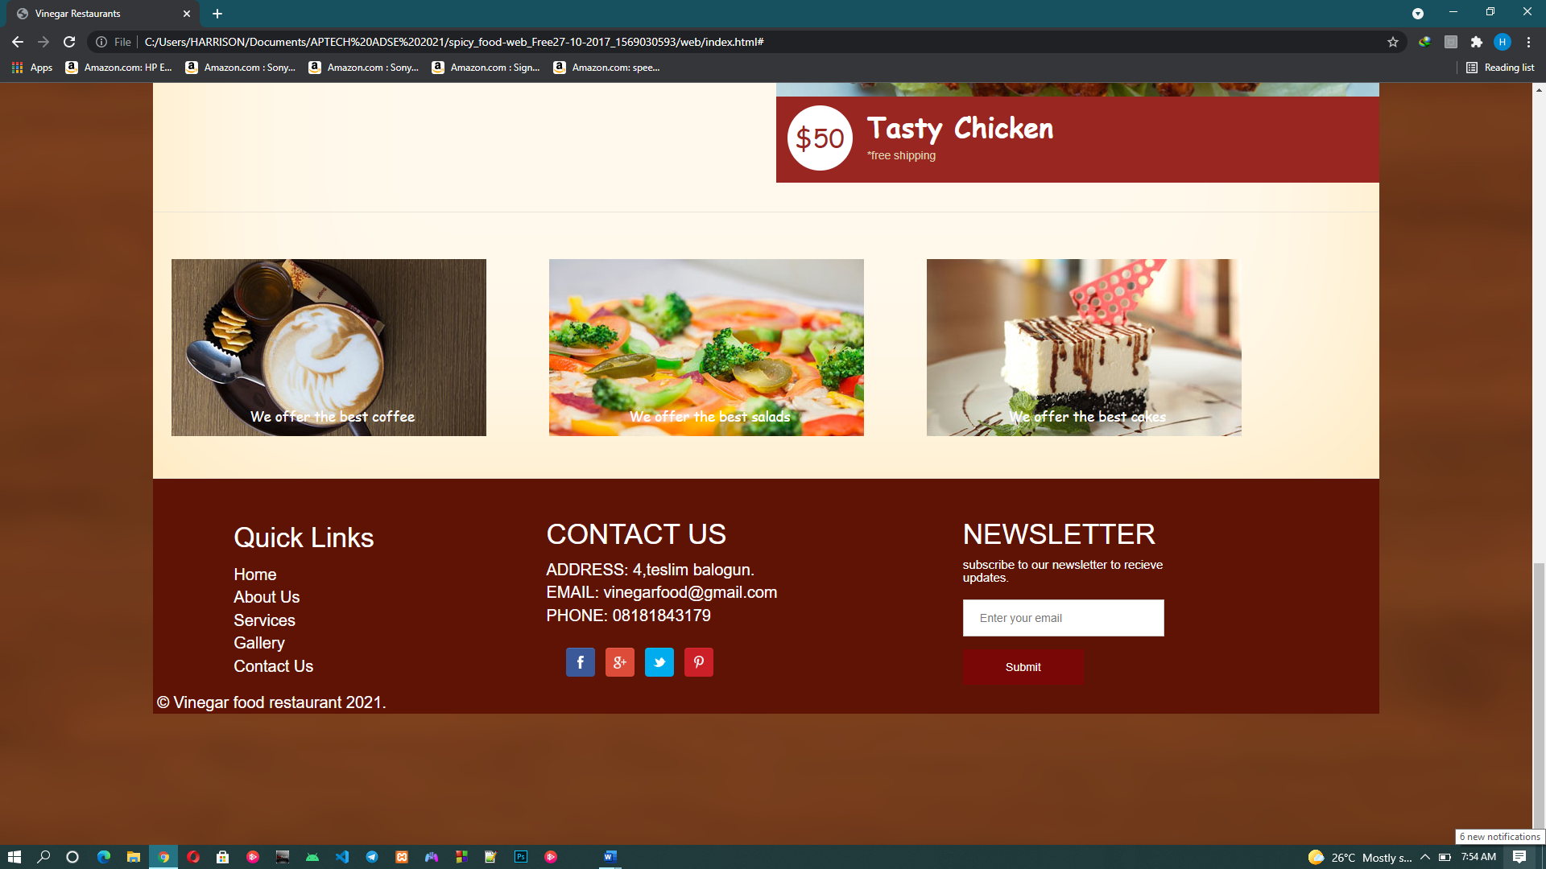

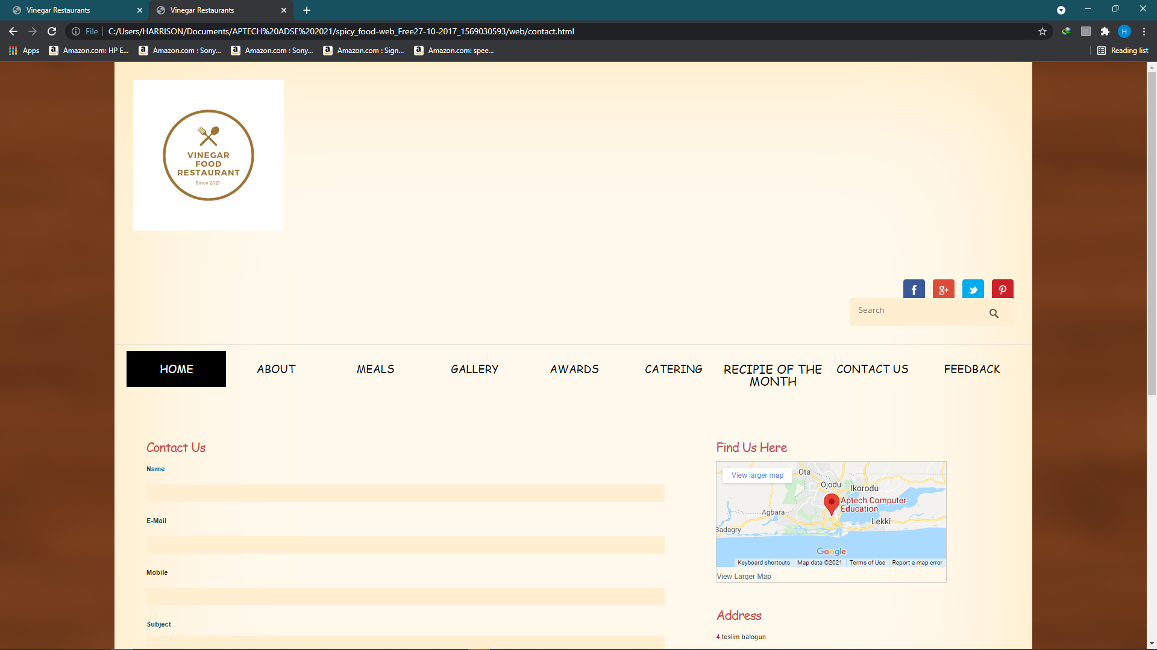

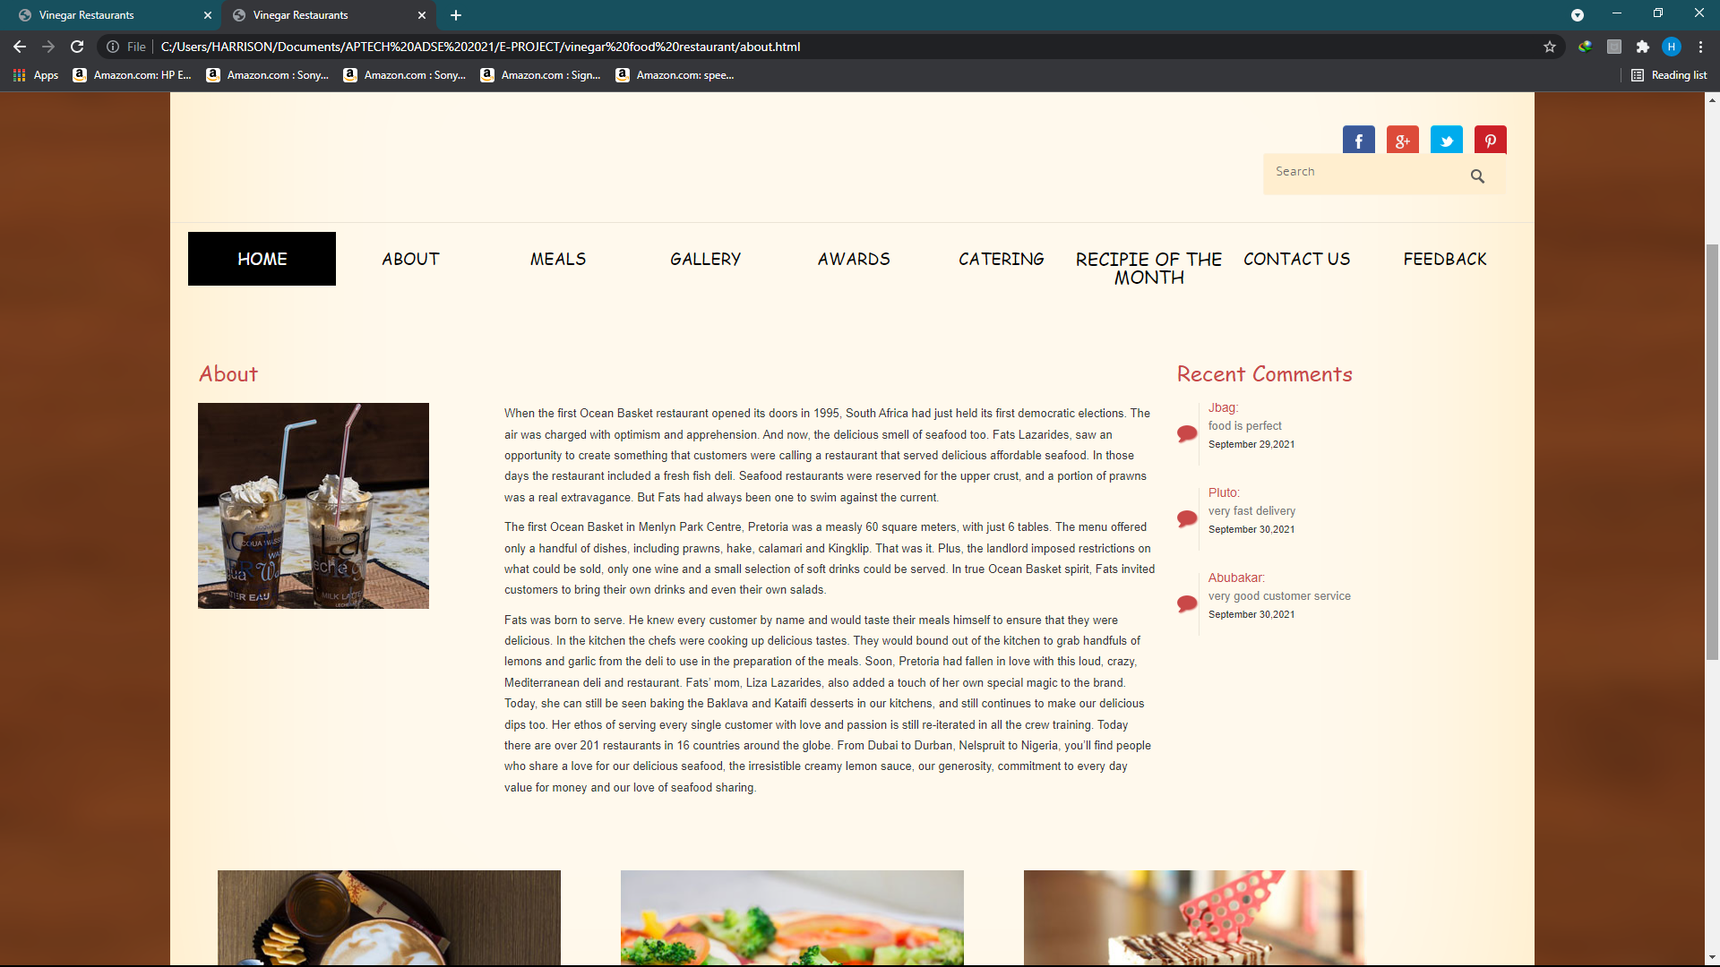

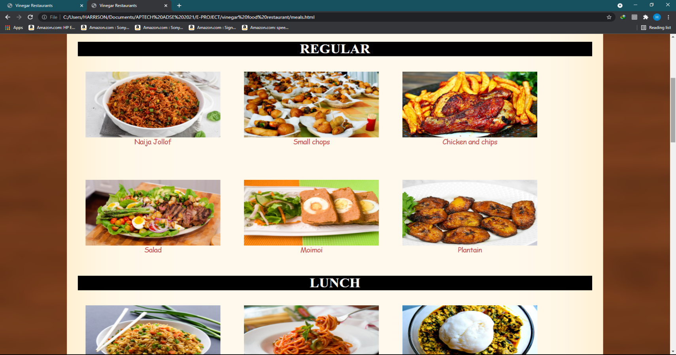

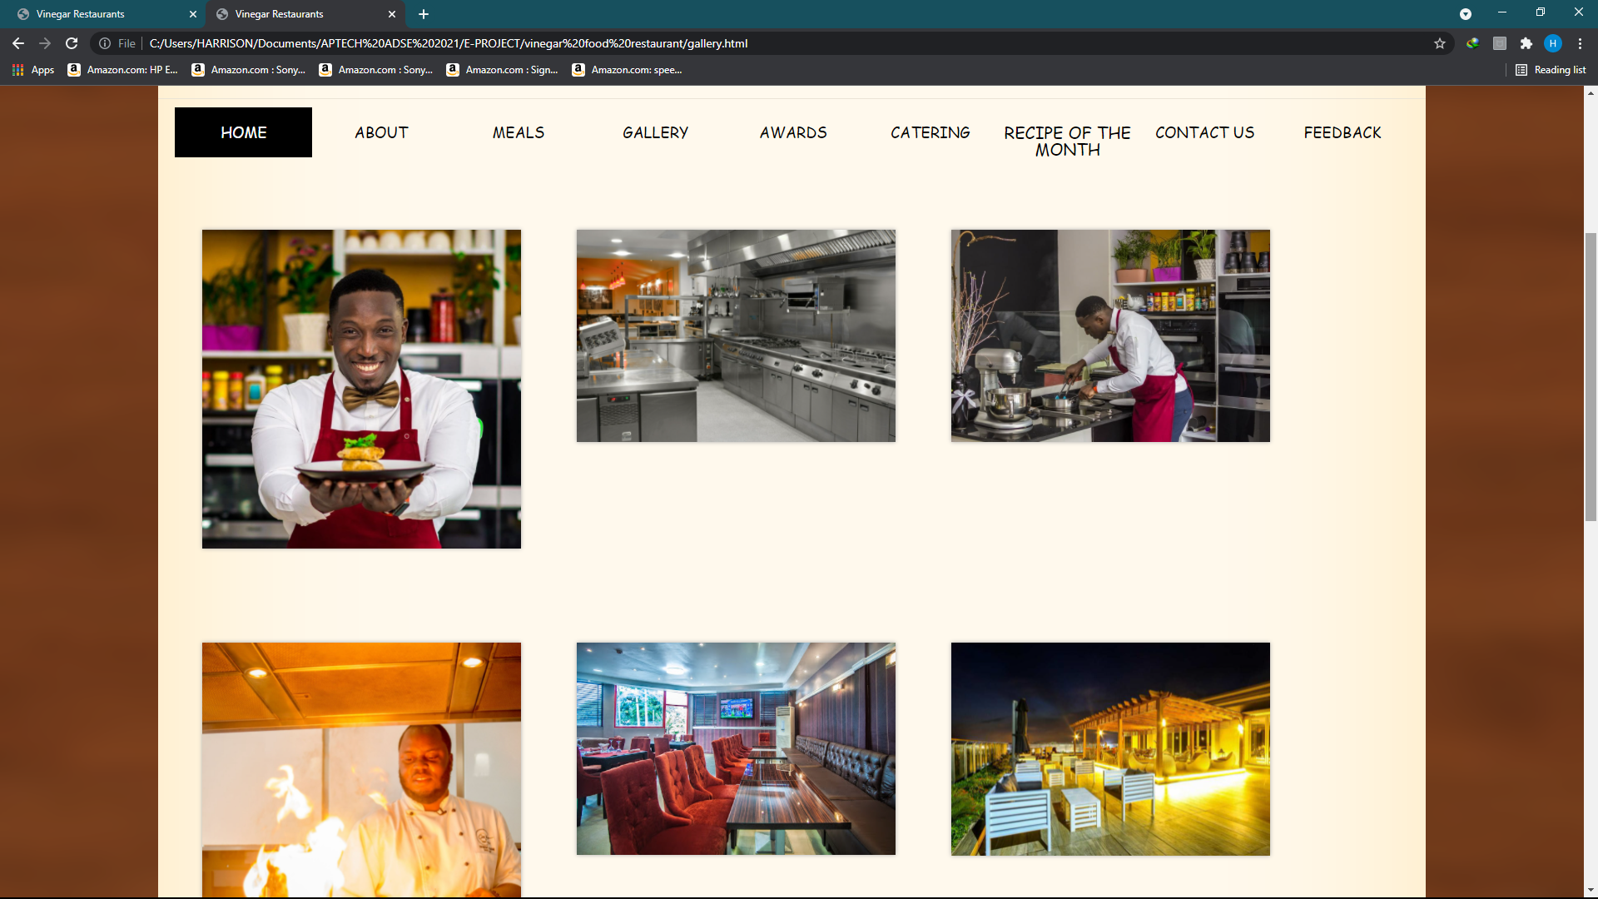

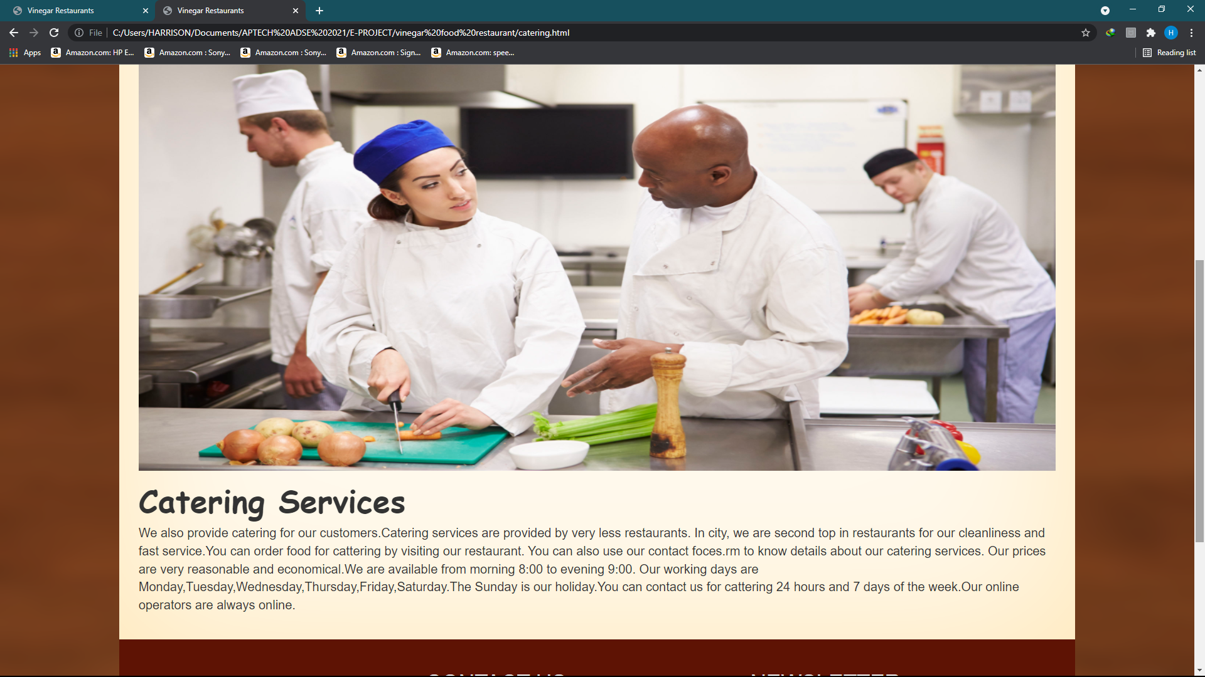

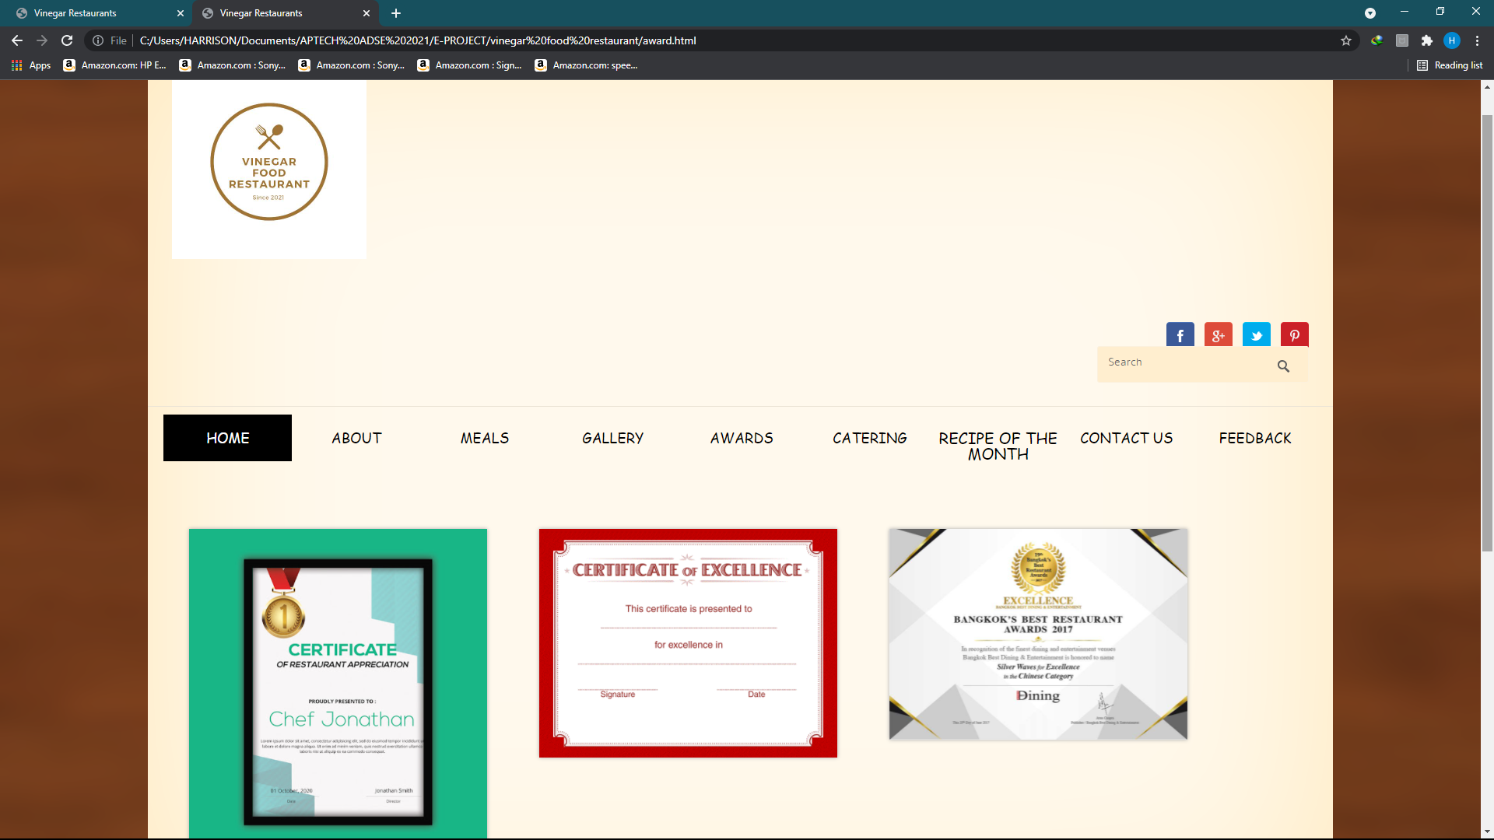

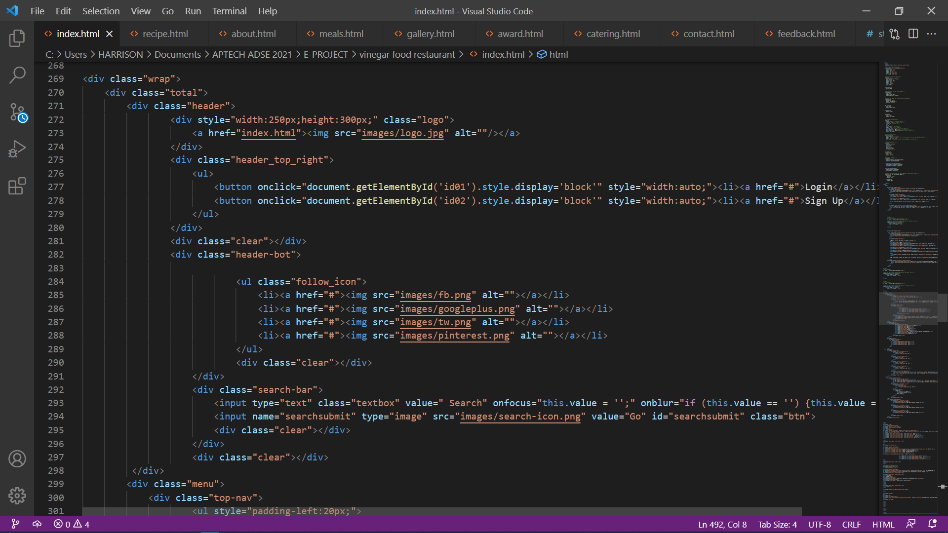**HTML**

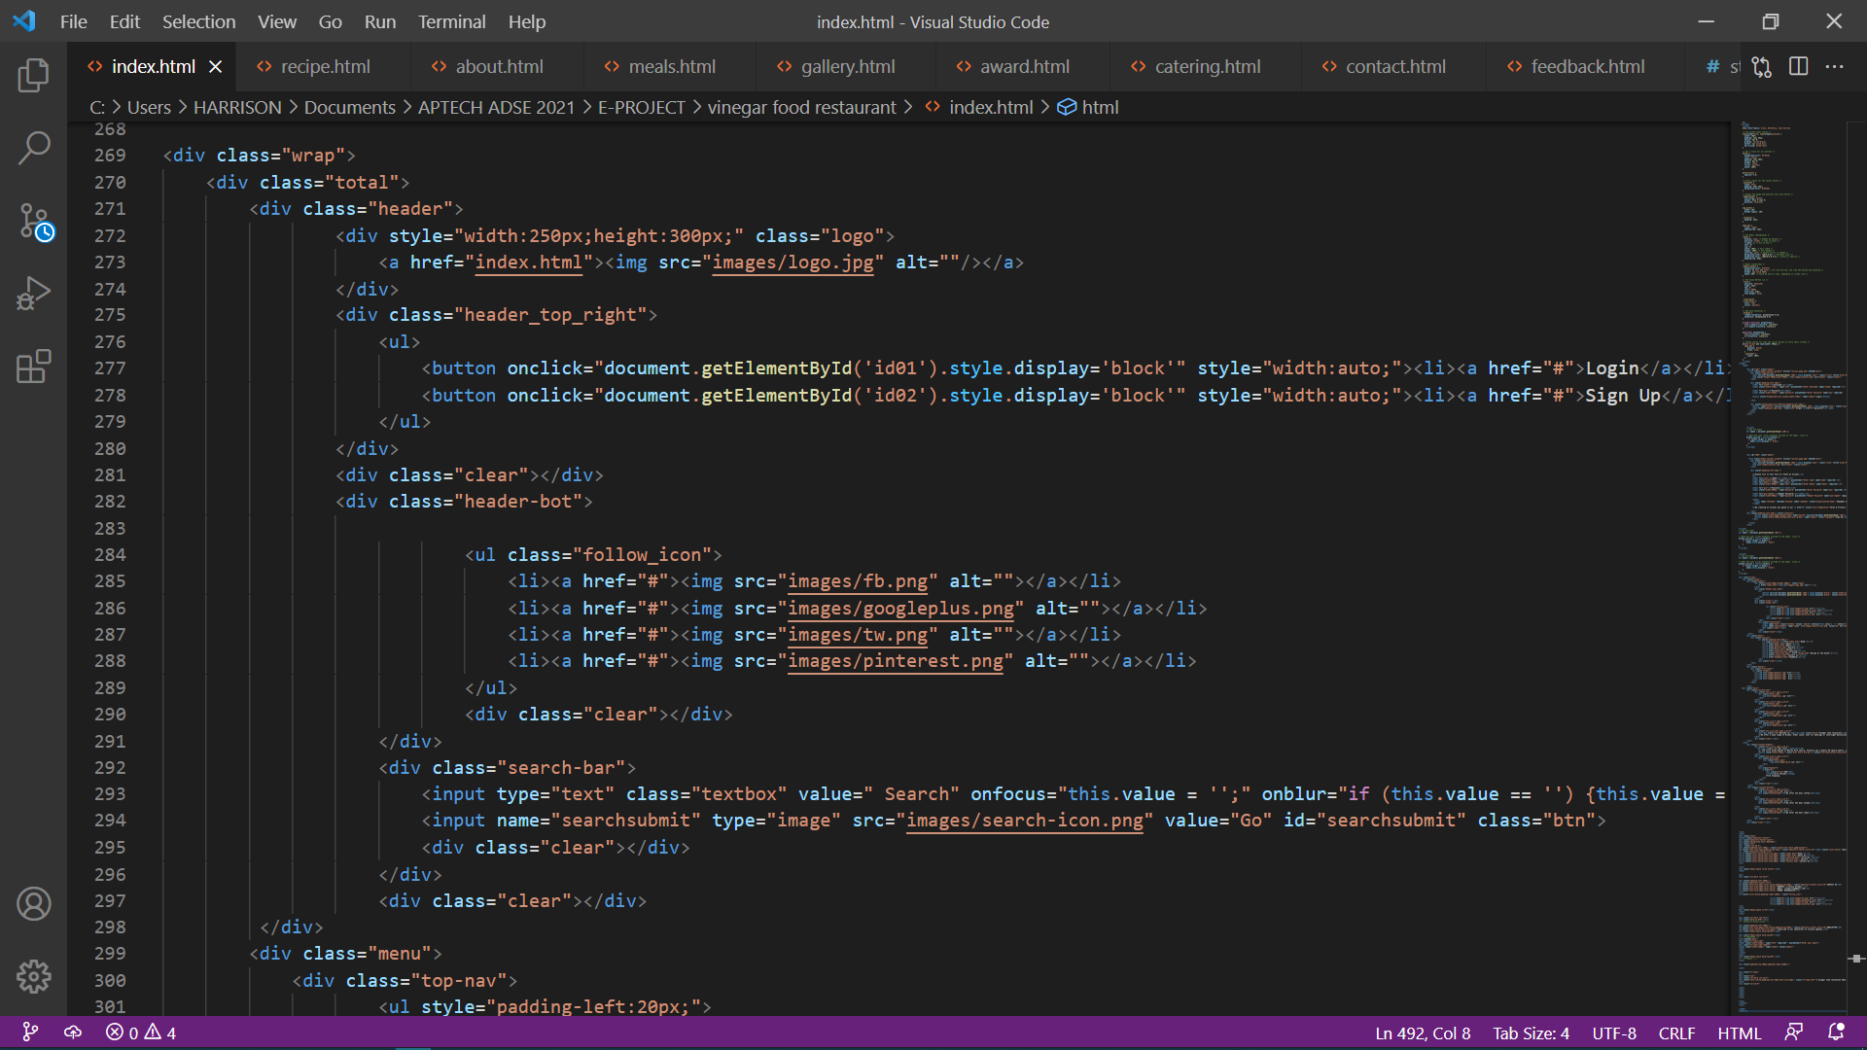

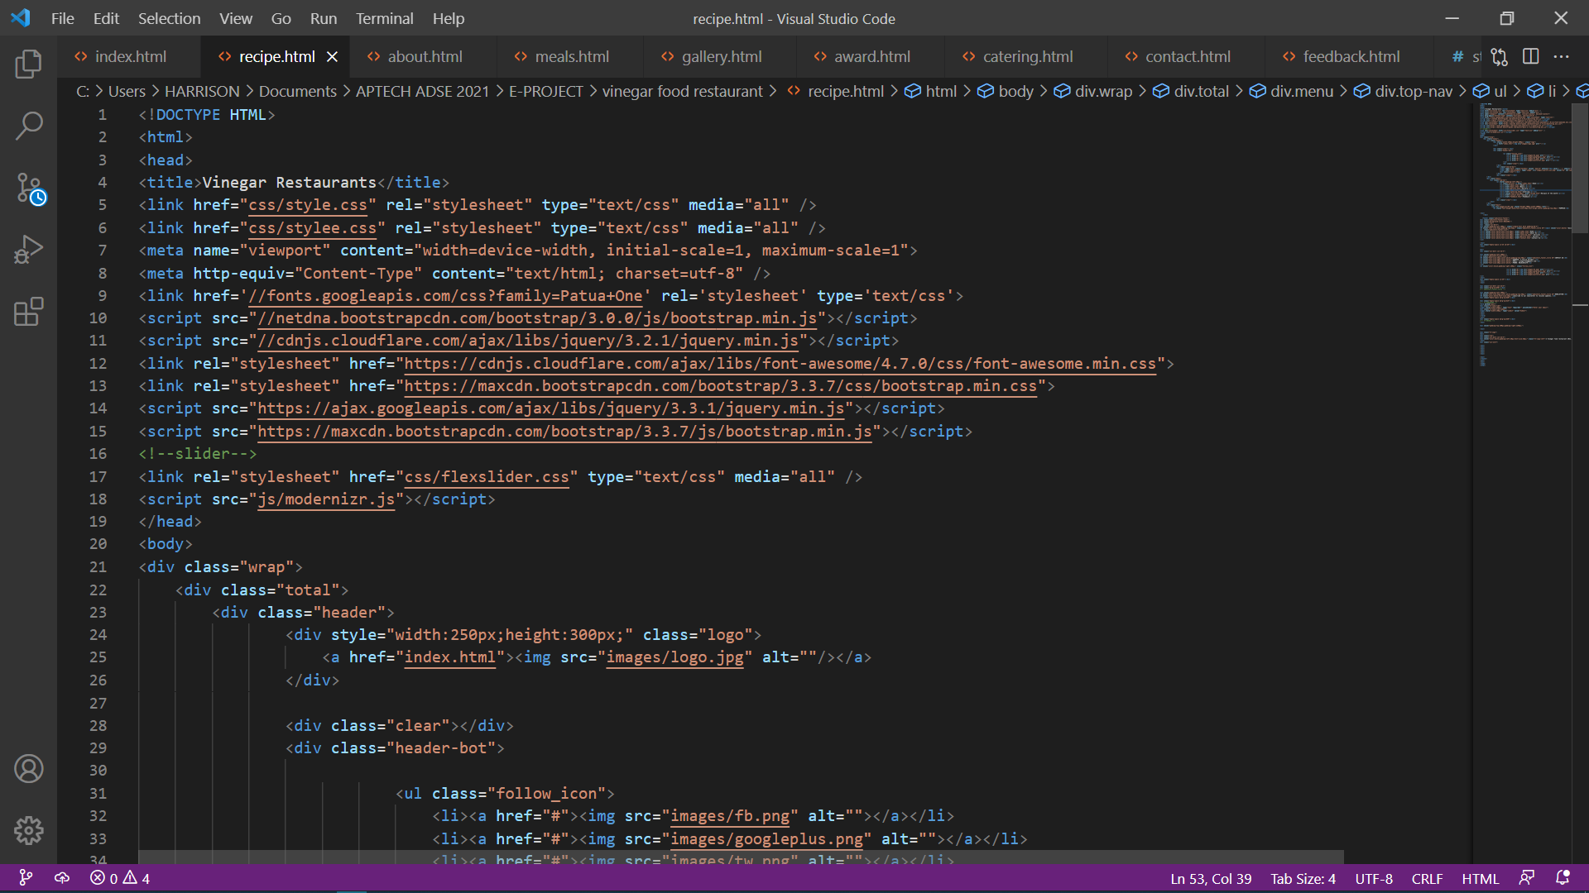

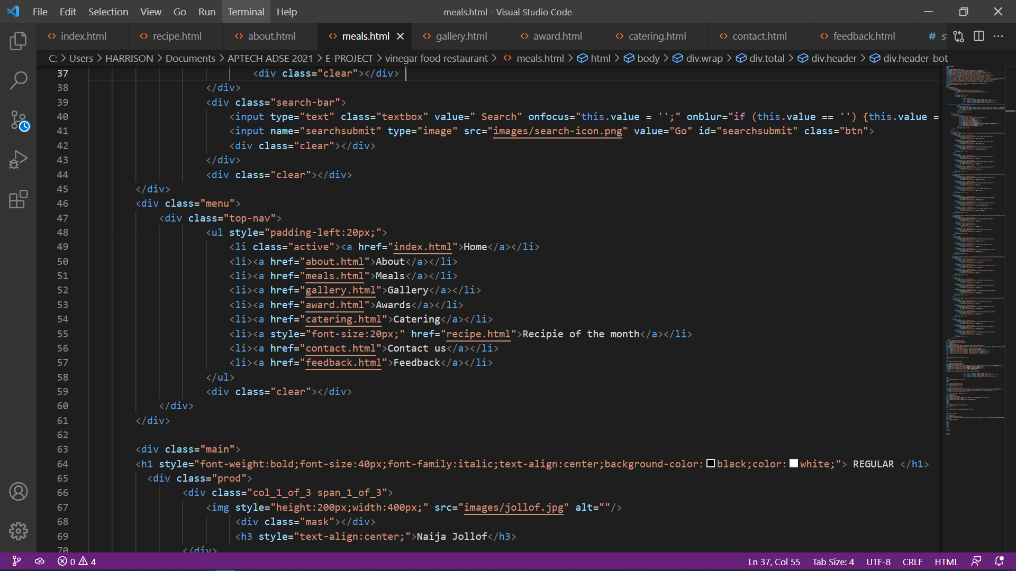

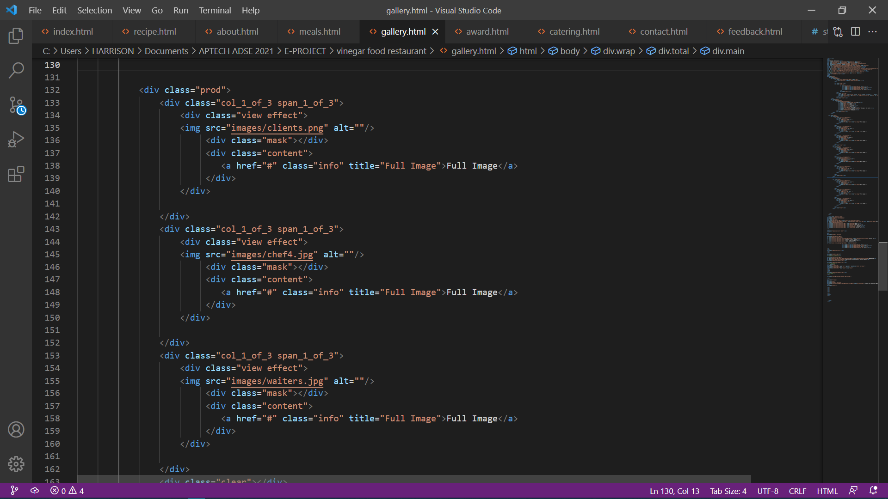

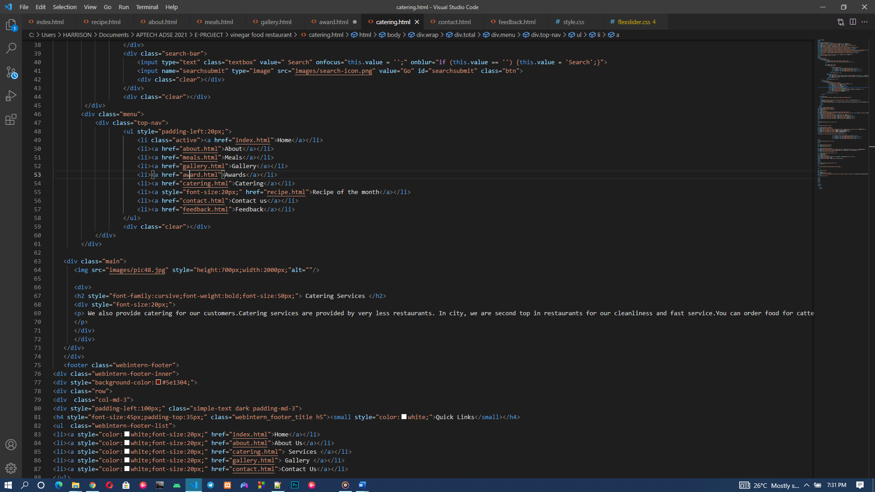

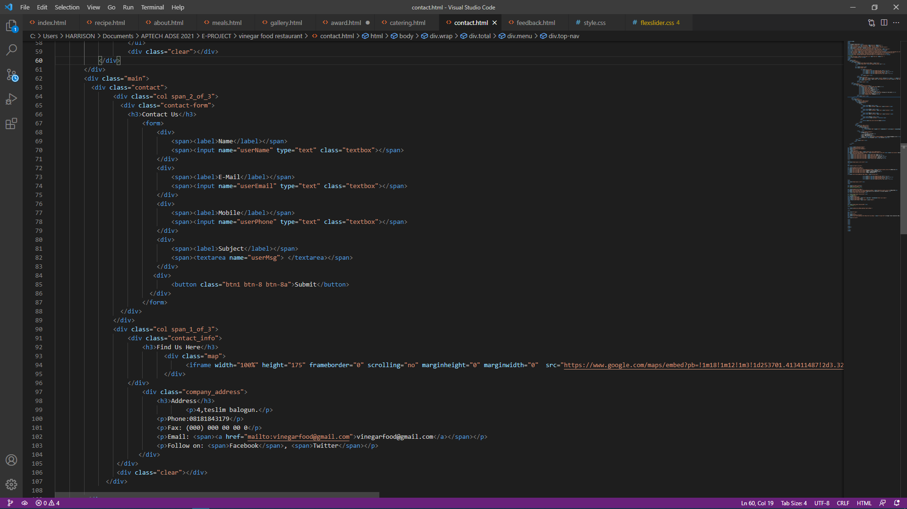

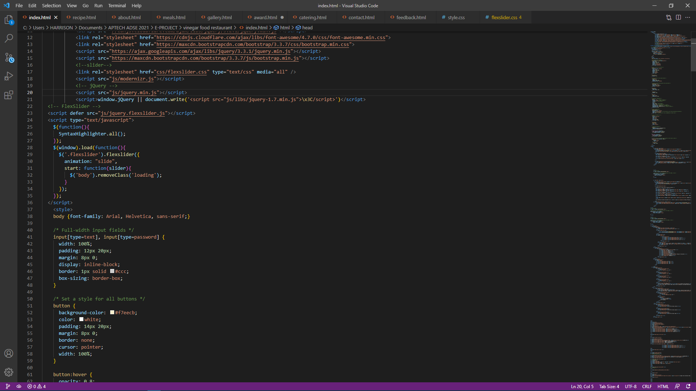JAVA SCRIPT / JQUERY

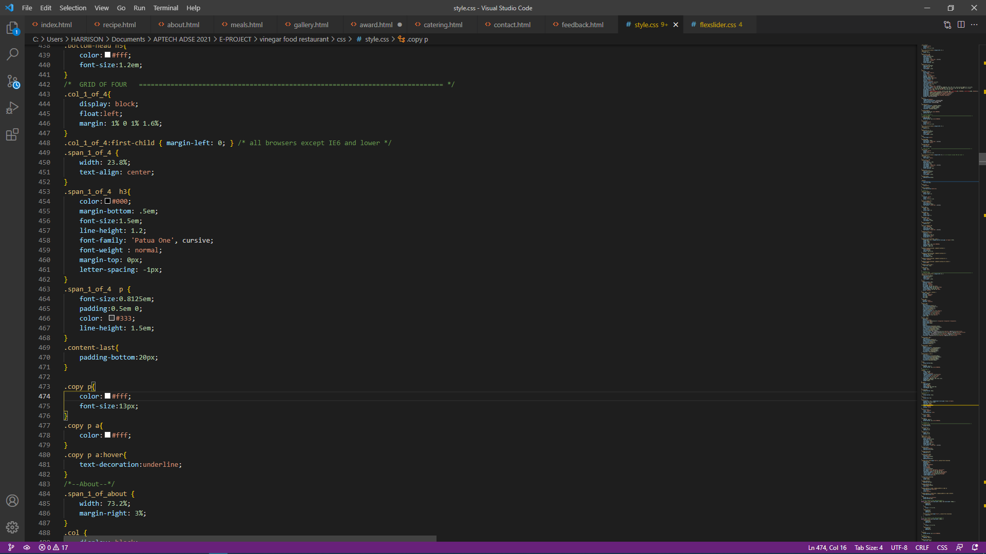CSS

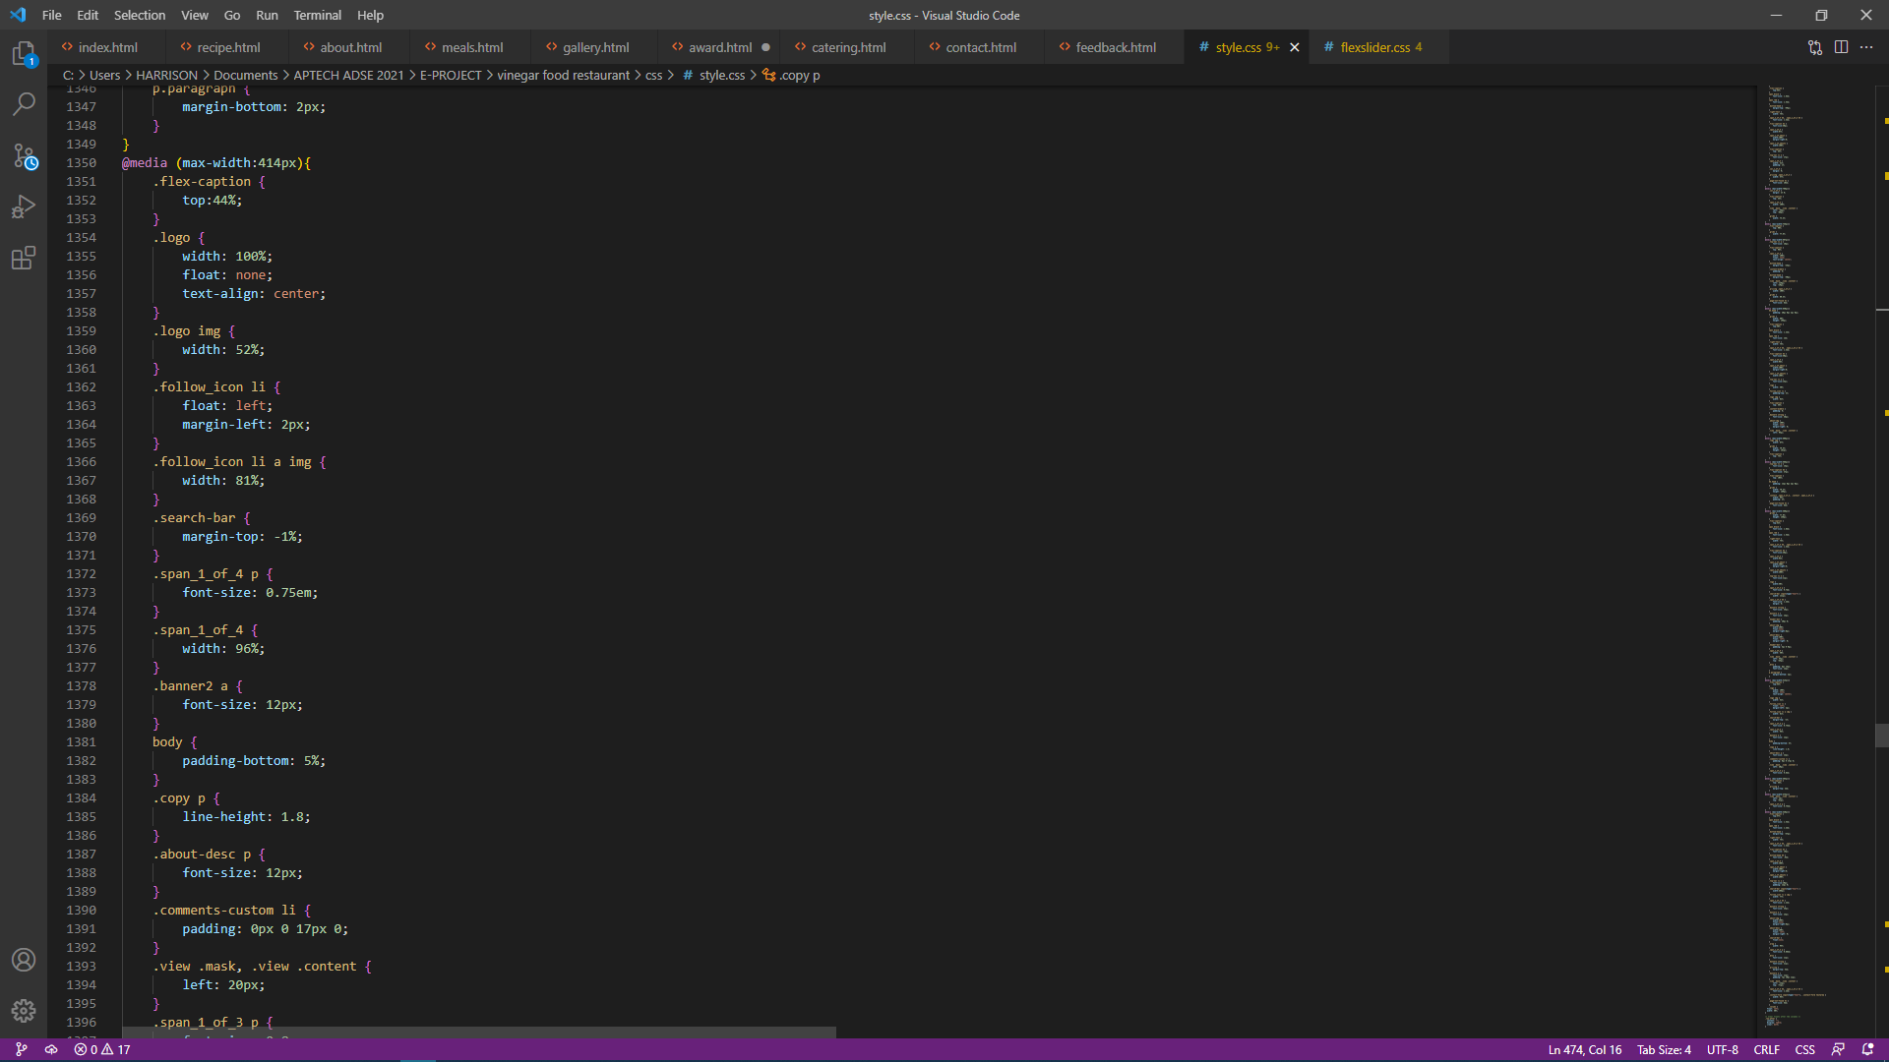

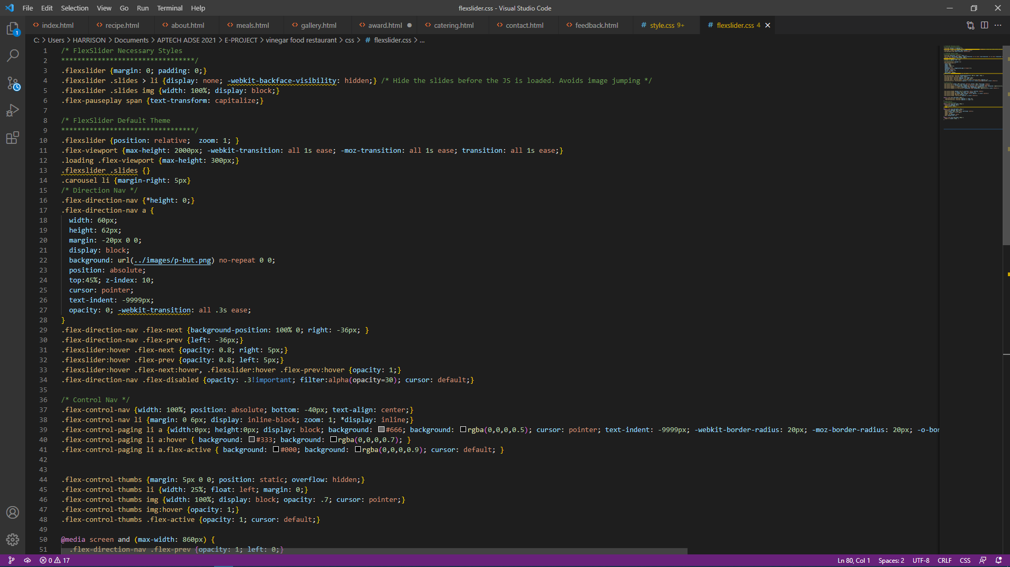

# **Developers guide**

**VINEGAR provides an easy shopping facility to the customers, wherein they can sit at one place and shop online anytime, anywhere 24/7.**

**If a developer wants to change any content of the website, the developer can access the index page and other html pages within the website.**

**The source code has been commented in detail in order for any developer going through the code to easily understand and modify.**

**The project was created using HTML5, CSS, and JavaScript.**

**Visual Studio Code was used as the HTML text editor, and it has been tested across all leading browser and various screen sizes.**